* Objective of our project is to conduct analysis and develop visualizations related to the Adverse Events based on complaints submitted to FDA for foods, dietary supplements and cosmetics since 2004. Our analysis of the data led to the following insights. Food reactions in the 41-60 age group is highest. The Female population is more prone reactions to food /cosmetics than the male population. July has the highest occurrence of food reactions compared to the rest of the year. 2017 had the highest reported cases of food & cosmetics reactions
* We were interested in understanding the frequency of adverse food reactions across age, gender and timing of the year. Additionally, we wanted to understand the product types that led to reactions so we can educate ourselves and spread awareness of risk involved in using the products within our families and community. We were curious to see if the dire outcome i.e death due to food reactions was more likely in a specific age group
* **What product type had the most adverse reactions?**

Vitamins/Dietary Supplements had the most adverse reactions per the chart below. We wondered, what ingredient is in Vitamins/Dietary Supplements that causes so many adverse reactions.

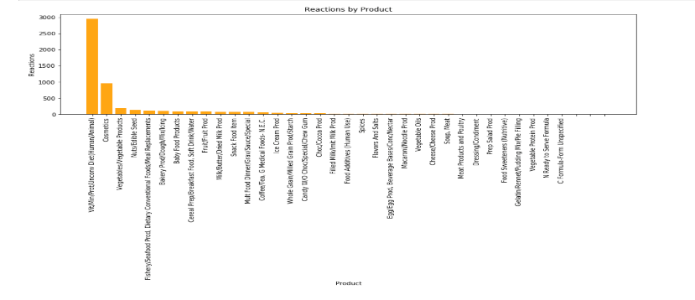

* **Do adverse reactions occur more during a certain time of year?**

July has a higher rate of adverse reactions compared to the other times in the year but the general distribution is uniform.

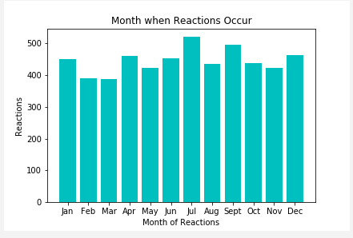

* **Have adverse reactions increased or decreased over the last 10 years?**

Adverse reactions have increased over the last 10 years and peaked in 2017 based on the visual of the line graph below.

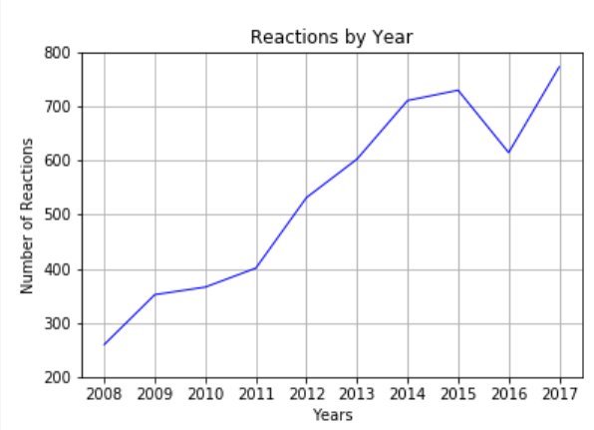

* **Do males or females report more adverse reactions?**

Females are more than 2 times likely to report the reaction and take action (go to the ER etc.) compared to males.

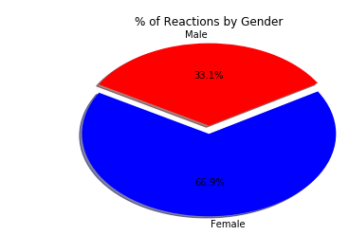

* **Which age group reports the most adverse reactions?**

41-60 Age Group reports and diagnosed the most adverse reactions. We also know that reactions to products is different for different people and there is no pattern we could associate.

If time allowed, we would have liked to research if this age group was higher because people start to see a change in their digestion compared to when they were younger. Consumption reaction at 20 vs 41 with the exact same product.

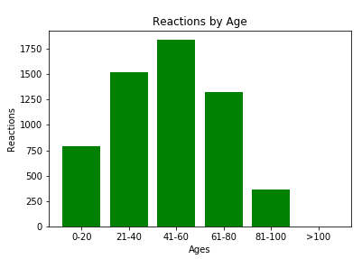

* **What are the most common reactions by product**

Alopecia, Choking and Vomiting are the most common reactions to the products reported.

If time allowed, we would have liked to find the % of males and females that experiences alopecia (highest ranking reaction).

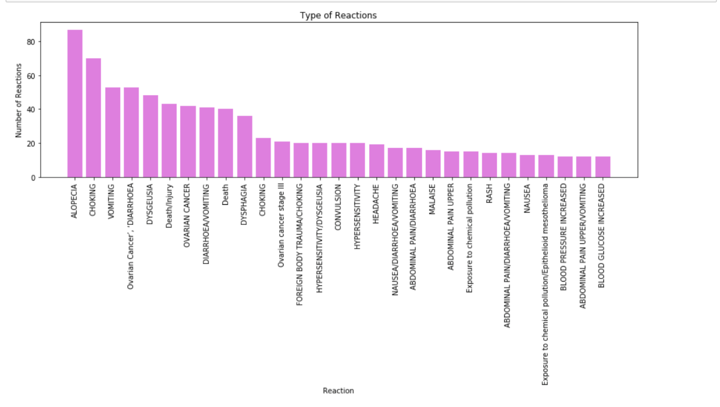

* **How many outcomes and reactions were reported by each person?**

In most observations the person only experienced one reaction. There were several incidents where the person experienced more than a few reactions at a time.

We also pondered on the question - Did the person really have 38 reactions?

If time allowed, we would have liked to see how long some reactions lasted and how did they handle these products after this observation?

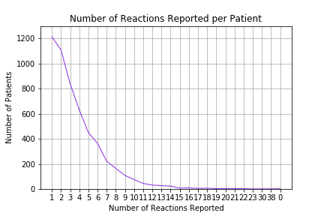

Per the observation, the person only experienced one outcome such as going to the hospital emergency room, visiting their physician, becoming disable, having a life-threatening moment, and unfortunately death. There were serval incidents where there were no outcomes listed. We wonder is listed, how this would have changed the data.

